Magnetic field
1. magnetic field due to current-carrying wire
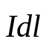
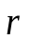
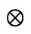
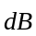
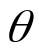
(1) The Biot-Savart Law )
P
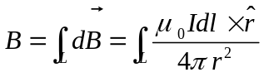
： Displacement vector from the current element to the filed point
Application:

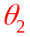
(a) magnetic field due to long straight wire
x
x
O
I
P
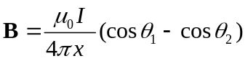
A infinitely long wire ： 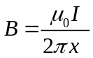

(b) magnetic field due to current loop) (I,R,x) 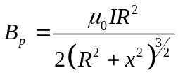 direction:
O
P
x
R
I

At the center ：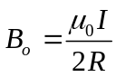
(c) magnetic field along the axis of a long solenoid
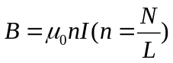
(2) magnetic field due to moving charges
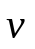
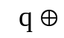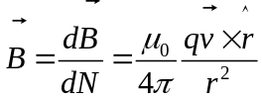
P
(3) Ampère ’s law
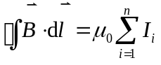
The line integral of the magnetic field around a closed path is equal to 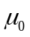 times algebraic sum of the currents enclosed by the path.
Application：
(a)magnetic field due to a solid cylindrical wire (R,I)
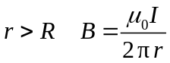
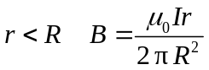
(b)magnetic field of a long solenoid
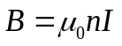
(c) magnetic field of a torpid
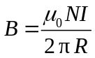
(4) Gauss's law for magnetism

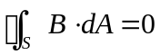
The net magnetic flux through any closed surface is equal to zero.

2. magnetic force
(1) magnetic force on current-carrying wire (Amplere’s force)
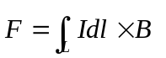
In uniform magnetic field
For any shape wire
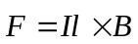
For closed loop
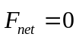
(2) Torque on a current loop

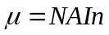 magnetic （dipole） moment（磁[偶极]矩）
direction：right-hand rule
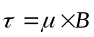 torque on a current loop
The magnetic flux tend to be maximum only under the magnetic force.
(3) magnetic force on moving charges （Lorentz force）

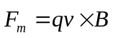
- Uniform magnetic field
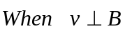
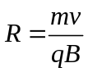 （Radius） 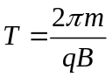 （Period）
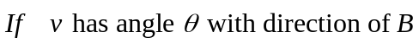
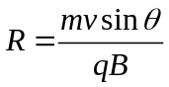 Cyclotron Radius
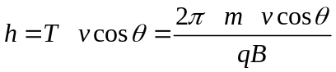 Pitch
(c) Charges moving in both electric and magnetic fields“
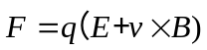 （The Lorentz equation）

(4) The hall effect
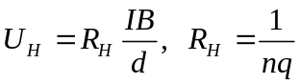
3. magnetic Materials
(1) All materials are magnetic to some extent. There are three kinds of magnetic materials.
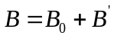
a. Paramagnetic(顺磁质） 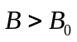
b. Diamagnetic(抗磁质） 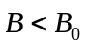
c. Ferromagnetic (铁磁质） 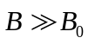
(2) 介质中的安培环路定理

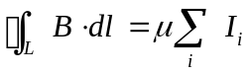
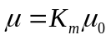
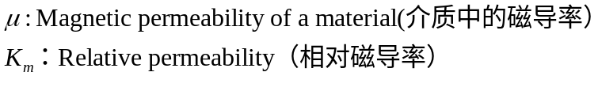
注意：对I 的求和并不包括束缚电流，因为束缚电流对磁场的贡献已经包含在μ中。
3 铁磁质
铁磁性材料有磁滞现象，在居里点由铁磁性向顺磁性转化
可分根据磁滞回线的面积的大小分为：
- 软磁材料；磁滞回线的面积小
- 硬磁材料；磁滞回线的面积大

